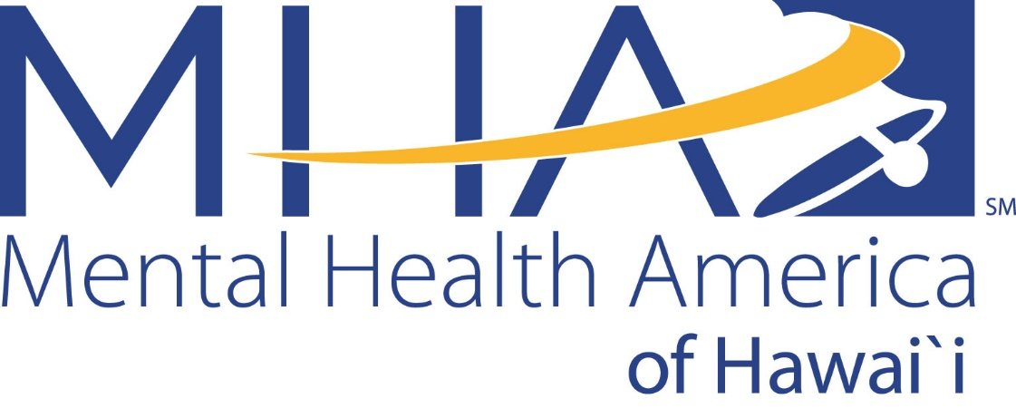

Art & Mental Health Request for Proposal Request

Through the ages, art has provided us with the means to express and reflect upon our deepest emotions. Artists change the world with the power of their creations and we believe that art can help us to break through the stigma of mental health challenges.
The topic of mental health is getting more attention than ever with people coming forward in the media to talk about their mental health and with younger generations playing a large role in normalizing the topic. Unfortunately, rates of mental health issues in youth are climbing and 66% of adults in Hawai‘i who need mental health treatment are not getting it. We know that stigma around mental health plays a big role in keeping people from seeking help.
Mental Health America of Hawai‘i (MHAH) is seeking a feature artist to create a piece for our third annual Art and Mental Health fundraising event on October 17, 2019, 5:00 – 8:00 pm at Café Julia in Honolulu. The selected artist will be awarded a $3,000 grant to cover all costs related to the artwork, including time, materials, production space and taxes.
This event celebrates creativity and the connection between art and mental health, allowing participants to talk about mental health in an open and accepting way. We’re looking for an artist to inspire us with a new or existing work and the willingness to share about their creative process and relationship to the topic of mental health. Your proposed art piece can be of any medium and must represent or portray a story about mental health that includes a message of hope.
Deadline for proposal submission is Monday, July 22, 9:00 am.
A group of finalists will be invited to present in-person to a selection body with 2 weeks’ notice. In-person presentations will be held on August 08. Finalists selection will be completed by July 26, 2019.
Submission of a proposal means that you can fulfill the following requirements:
- Present your proposal in-person during the evening of August 08 (if selected as a finalist).
- Complete your proposed piece by Monday, September 19, 2019.
- Attend the October 17, 2019 event at Café Julia (event time 5:00 – 8:00 pm).
- Keep in touch with MHAH staff throughout the process.
- Participate in media engagements (coaching provided) and photography leading up to the event.
- Provide a completed IRS Form W-9 before payment.
- Assist with fundraising ideas for the Art & Mental Health October event.

Summary of project timeline:
- Monday, July 22, 2019 9:00am –Deadline for submission of written proposal (see form)
- July 26, 2019 – Finalists selected and notified
- August 08, 2019 5pm-8:30pm – Finalist in-person presentations of proposal
- Monday, September 19, 2018 – Deadline for artwork completion
- Thursday, October 17, 2018 – Event date
To Submit your Proposal, you must:
- Fully fill out the accompanying Request For Proposal Form.
- If the artwork you are proposing has already been created, submit a photograph, print, or video of the art work.
- Submit samples of your previous art work either as photograph, print or video. If your work is already featured on your website or publicly available on social media, please provide links.
- Submit all proposal components to info@mentalhealthhawaii.org, or drop off all materials by Monday, July 22 at 9am at 1136 Union Mall, Suite 510, Honolulu HI 96813.
No late entries will be allowed. If you have any questions, please contact info@mentalhealthhawaii.org.

Mental Health America of Hawaii

Art & Mental Health Request for Proposal Submission Form

Please complete all the information below by typing or writing out the information.
Artist Name: ____________________________________________________________________________________
Mailing Address: _________________________________________________________________________________
Phone Number:______________________________ E-mail:___________________________________________
Website:____________________________ Social Media Handles:_______________________________
Name of the Work:__________________________________________________________________
Artistic Medium:____________________________________________________________________
Please give 1 paragraph (approximately 1/3 page) answer to each of the following questions. Add additional pages as needed:
- Describe your piece and the idea or story it will share about mental health.

- How will a message of hope be integrated into your piece and presentation?

- How does the idea of de-stigmatizing mental health issues resonate with you?

Please submit this form and your supporting material to info@mentalhealthhawaii.org, or drop off all materials by Monday, July 22 at 9am at 1136 Union Mall, Suite 510, Honolulu HI 96813. Call (808)521-1846 in advance to coordinate drop-off.

